Федеральное государственное образовательное бюджетное

учреждение высшего образования

**«Финансовый университет при Правительстве Российской Федерации»**

**(Финансовый университет)**

Колледж информатики и программирования

**ОТЧЕТ О ВЫПОЛНЕНИИ ЗАДАНИЯ**

**Тема:** Изучение библиотеке Anime.JS

Студент: Кириллов К.А.

Группа: 4ИСИП-619

Преподаватель: Сибирёв И.В.

Дата: 07.03.2023

Москва

2023

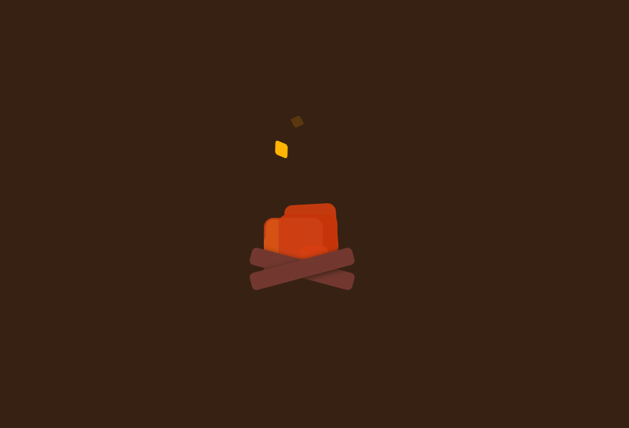

Рис 1. Страница сайта с анимацией

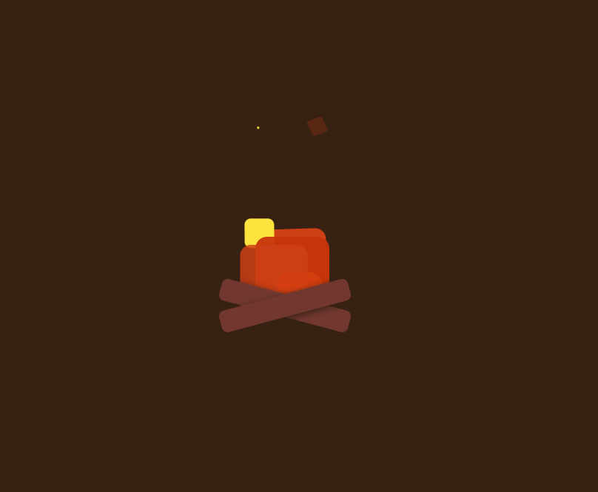

Рис 2. Страница сайта с анимацией

В данной программе реализован анимированный огонь.

Код программы:

Код HTML

<!DOCTYPE html>

<html lang="en" >

<head>

<meta charset="UTF-8">

<title>CodePen - Simple campfire</title>

<link rel="stylesheet" href="https://cdnjs.cloudflare.com/ajax/libs/meyer-reset/2.0/reset.min.css">

<link rel="stylesheet" href="./style.css">

</head>

<body>

<body>

<div class="cf-container">

<div class="cf-flame-container" id="fireNodes1">

<div class = "cf-flame"></div>

<div class = "cf-flame"></div>

<div class = "cf-flame"></div>

<div class = "cf-flame"></div>

<div class = "cf-flame"></div>

<div class = "cf-flame"></div>

<div class = "cf-flame"></div>

</div>

<div class="cf-flame-container" id="fireNodes2">

<div class = "cf-flame"></div>

<div class = "cf-flame"></div>

<div class = "cf-flame"></div>

<div class = "cf-flame"></div>

<div class = "cf-flame"></div>

<div class = "cf-flame"></div>

<div class = "cf-flame"></div>

</div>

<div class="cf-flame-container" id="base-fire">

<div class = "cf-flame"></div>

<div class = "cf-flame"></div>

<div class = "cf-flame"></div>

</div>

<div class= "cf-log-container">

<div class="cf-log"></div>

<div class="cf-log"></div>

<div>

</div>

</body>

<script src='https://cdnjs.cloudflare.com/ajax/libs/animejs/3.2.0/anime.min.js'></script><script src="./script.js"></script>

</body>

</html>

Код CSS

body {

background-color: #372113;

width: 100vw;

height: 100vh;

position: relative;

}

.cf-container {

box-sizing: content-box;

width: 300px;

height: 300px;

position: relative;

top: 50%;

left: 50%;

transform: translate(-50%, -50%);

}

.cf-container .cf-flame-container {

width: 100px;

height: 100px;

bottom: 0px;

position: absolute;

}

.cf-container .cf-log-container {

width: 60%;

height: 100px;

position: absolute;

bottom: 0px;

left: 50px;

}

.cf-container .cf-flame-container#base-fire .cf-flame:nth-child(1) {

background: #c63509;

opacity: 0.95;

}

.cf-container .cf-flame-container#base-fire .cf-flame:nth-child(2) {

background: #cd4015;

width: 100px;

height: 100px;

opacity: 0.85;

left: 75px;

}

.cf-container .cf-flame-container#base-fire .cf-flame:nth-child(3) {

background: #d73e0f;

width: 60px;

height: 60px;

opacity: 0.85;

left: 130px;

}

.cf-container .cf-flame-container:nth-child(2) {

width: 150px;

height: 150px;

bottom: 0px;

position: absolute;

}

.cf-container .cf-flame-container:nth-child(2) .cf-flame {

width: 75px;

height: 75px;

left: 75px;

}

.cf-log {

background: #723830;

width: 20px;

height: 30px;

transform-origin: center;

position: absolute;

bottom: 0px;

border-radius: 0.5em;

box-shadow: 0 3px 10px #372113;

width: 100%;

}

.cf-log:nth-child(1) {

transform: rotate(15deg);

}

.cf-log:nth-child(2) {

transform: rotate(-15deg);

}

.cf-flame:nth-child(1) {

background: #f5ed8f;

}

.cf-flame:nth-child(2) {

background: #fde239;

}

.cf-flame:nth-child(3) {

background: #ffdc01;

}

.cf-flame:nth-child(4) {

background: #fdac01;

}

.cf-flame:nth-child(5) {

background: #d73e0f;

}

.cf-flame:nth-child(6) {

background: #cd4015;

}

.cf-flame:nth-child(7) {

background: #c63509;

}

.cf-flame:last-child {

background: #c63509;

}

.cf-flame {

background: #cd4015;

width: 100px;

height: 100px;

border-radius: 1em;

position: absolute;

bottom: 0px;

left: 100px;

}

#fireNodes2 .cf-flame {

-webkit-animation: flameColor 1.5s ease-out infinite;

animation: flameColor 1.5s ease-out infinite;

}

@-webkit-keyframes flameColor {

0% {

background: #c63509;

}

20% {

background: #cd4015;

}

30% {

background: #fdac01;

}

50% {

background: #ffb401;

}

60% {

background: #fdac01;

}

70% {

background: #ffdc01;

}

80% {

background: #fde239;

}

100% {

background: #f5ed8f;

}

}

@keyframes flameColor {

0% {

background: #c63509;

}

20% {

background: #cd4015;

}

30% {

background: #fdac01;

}

50% {

background: #ffb401;

}

60% {

background: #fdac01;

}

70% {

background: #ffdc01;

}

80% {

background: #fde239;

}

100% {

background: #f5ed8f;

}

}

Код JS

let fireNodes1 = document.querySelectorAll("#fireNodes1 .cf-flame");

let fireNodes2 = document.querySelectorAll("#fireNodes2 .cf-flame");

let fireNodes3 = document.querySelectorAll("#fireNodes1 .cf-flame");

let baseFire = document.querySelectorAll("#base-fire .cf-flame");

function animateBaseFire() {

anime({

targets: baseFire,

delay: anime.stagger(300),

translateY: function(){return anime.random(0, -10);},

keyframes: [

{scale: .8},

{scale: .825},

{scale: .9},

{scale: .925},

{scale: 1}

],

duration: 300,

easing: 'easeInOutSine',

loop: true,

})

}

function animateFlame1() {

anime({

targets: fireNodes1,

delay: anime.stagger(100),

translateY: function(){return anime.random(0, 300);},

rotate:30,

opacity:function(){return anime.random(.5, 1);},

translateX: function(){return anime.random(0, -60);},

scale:0,

skew: function () {return anime.random(0, 10);},

loop: true,

easing: "easeInOutSine",

})

}

function animateFlame2(){

anime({

targets: fireNodes2,

delay: anime.stagger(400),

translateX: function(){return anime.random(-30, 0);},

translateY: function(){return anime.random(0, -260);},

translateY: function(){return anime.random(-260, -160);},

translateX: function(){return anime.random(0, -30);},

scale:0,

rotate: function() { return anime.random(0, 60); },

skew:function(){

return anime.random(0, 30);

},

loop: true,

easing: "easeInOutSine"

})

}

function animateFlame3() {

anime({

targets: fireNodes3,

delay: anime.stagger(500),

translateY: function(){return anime.random(-300, -200);},

opacity:function(){return anime.random(0, 1);},

translateX: function(){return anime.random(-50, 50);},

scale:0,

rotate: function() { return anime.random(0, -30); },

skew: function () {return anime.random(0, 20);},

loop: true,

easing: "easeInOutSine",

})

}

animateFlame1();

animateFlame2();

animateFlame3();

animateBaseFire();



